**TOPIC: Impacts of microplastics on freshwater ecosystems and urban populations (EVERY urban city in Cali).**

**What to Research:**

1. Impacts of microplastics on [Insert major city in California] - I need top 15 cities!
2. Impacts of microplastics on freshwater ecosystems (California in general, or SF Bay)
3. Possible solutions/Current solutions/effectivity
4. Impacts of microplastics on farmland
5. IF YOU HAVE ANYTHING ELSE, ASK @theblindrat. !!!!

Stuck? Use this-

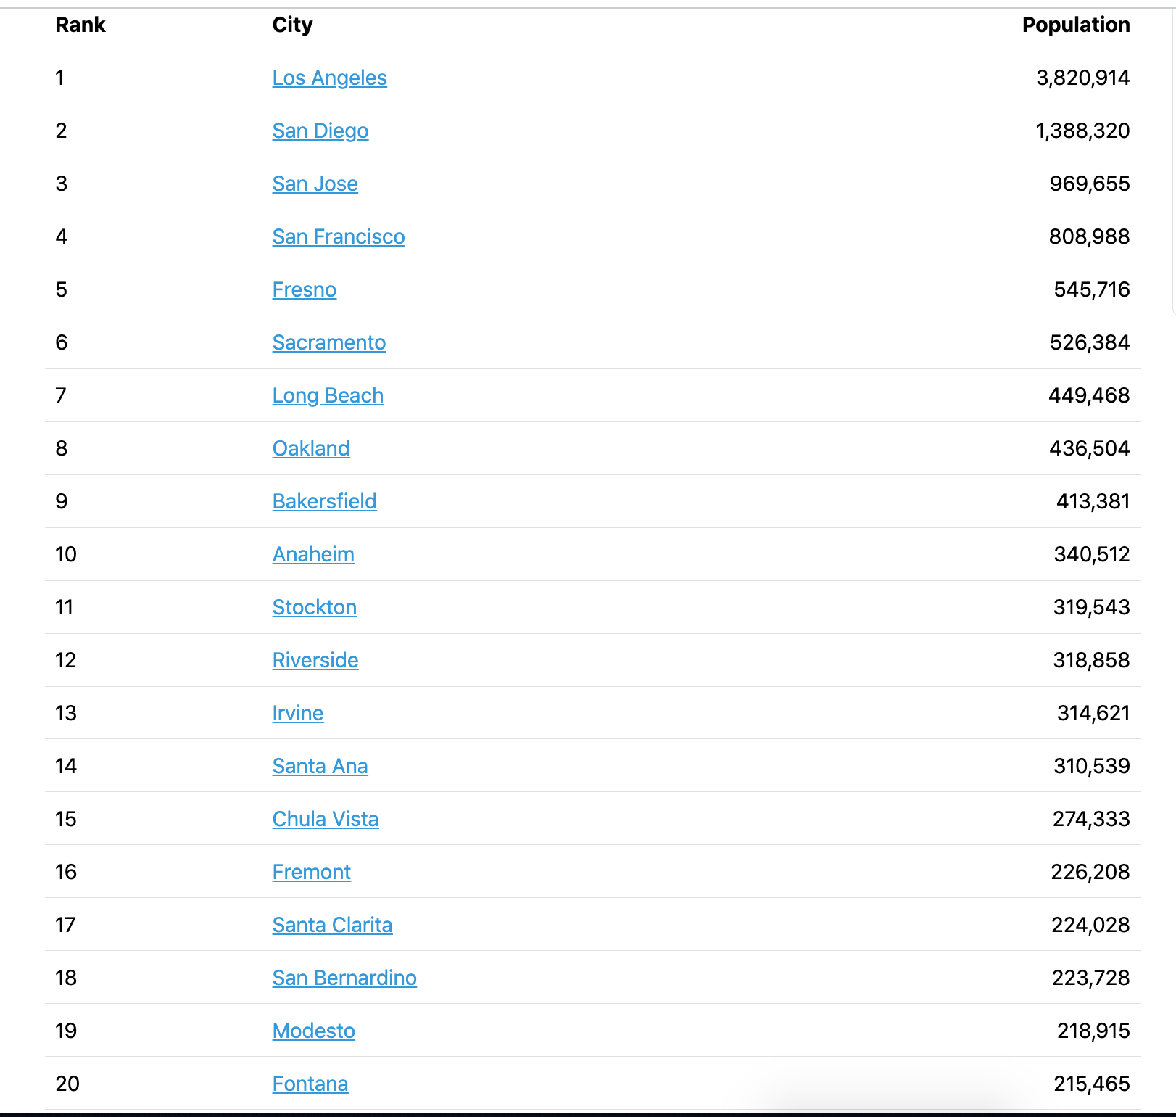

**NOTES:**    
Bullet point format is OK.   
Do NOT use ChatGPT/Deepseek/Wikipedia/Other AI as a source

Please format so we can read your notes  
Please report to @CEO or @CEO Of Operations after you are done.

Please follow basic Google Docs etiquette you learned during COVID.

This is Doc’s pageless format so please dont freak out.

**Research 2/20:**

**Research 2/21:**

**Research 2/22:**

**Research 2/23:**

**Research 2/24:**

**Research 2/25:**

**Research 2/26:**

**Research 2/27:**

**Research 2/28:**

**Research 2/29:**

**Research 2/30:**

**Other to be added…**